**Assignment – III**

Jyothi Swaroop Meruga (#244463)

Shilpa Kodali (#246727)

Shruti Hardia (#245853)

Sudheer Kumar Mogili (#244956)

PART – I

* Download tomcat server from <http://tomcat.apache.org/download-80.cgi> and install it in your machine
* Now configure the server in to your IDE (in this case since I am use eclipse I configured it in eclipse)

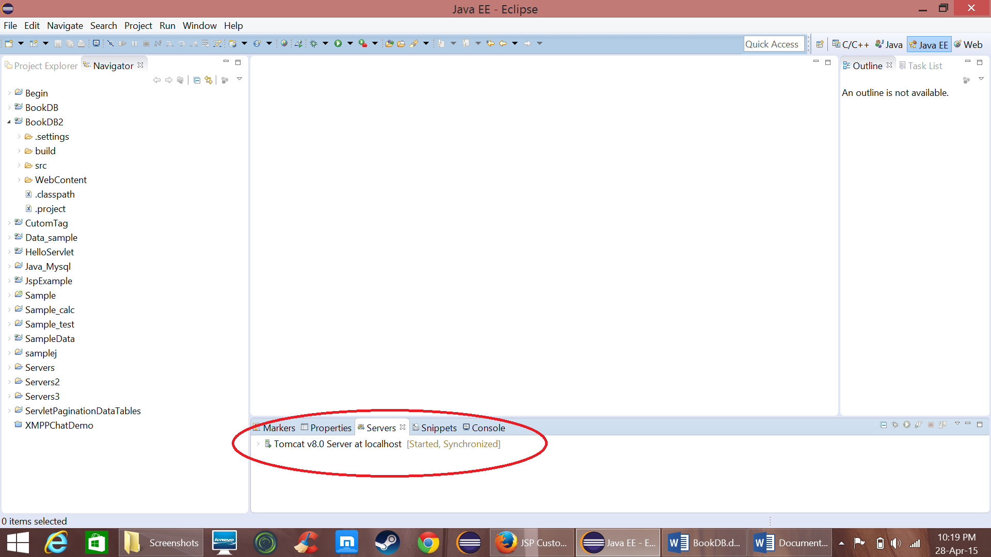

* 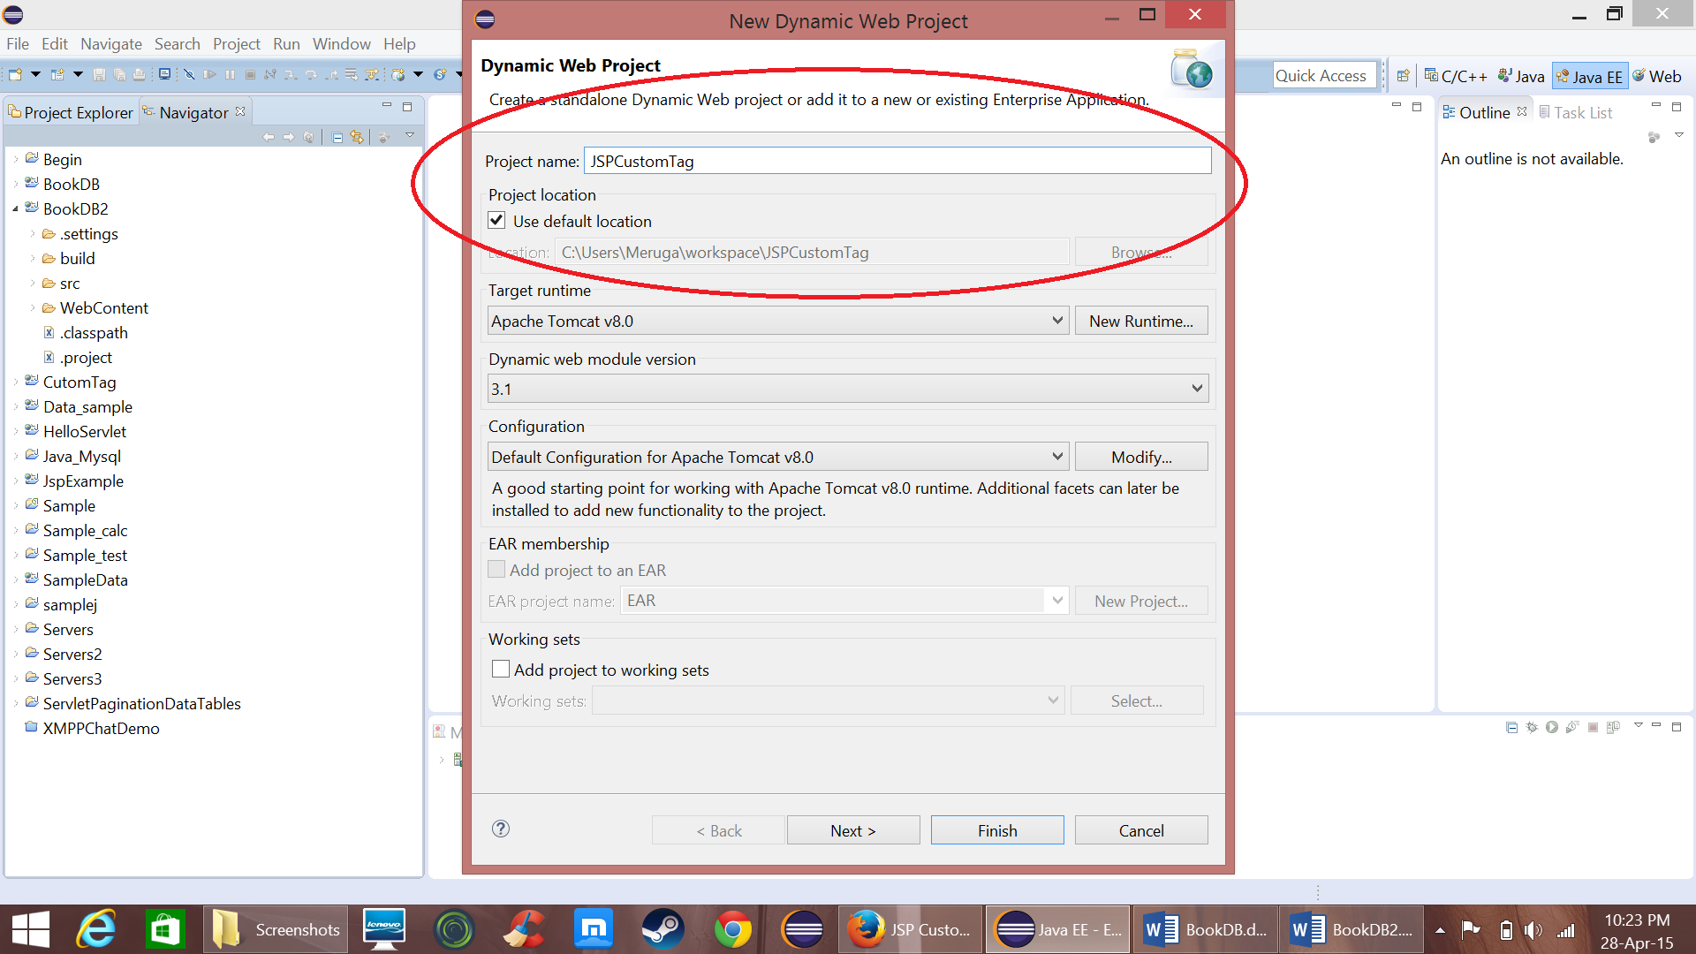Now create a “dynamic web project” and name it as “JSPCustomTag”
* 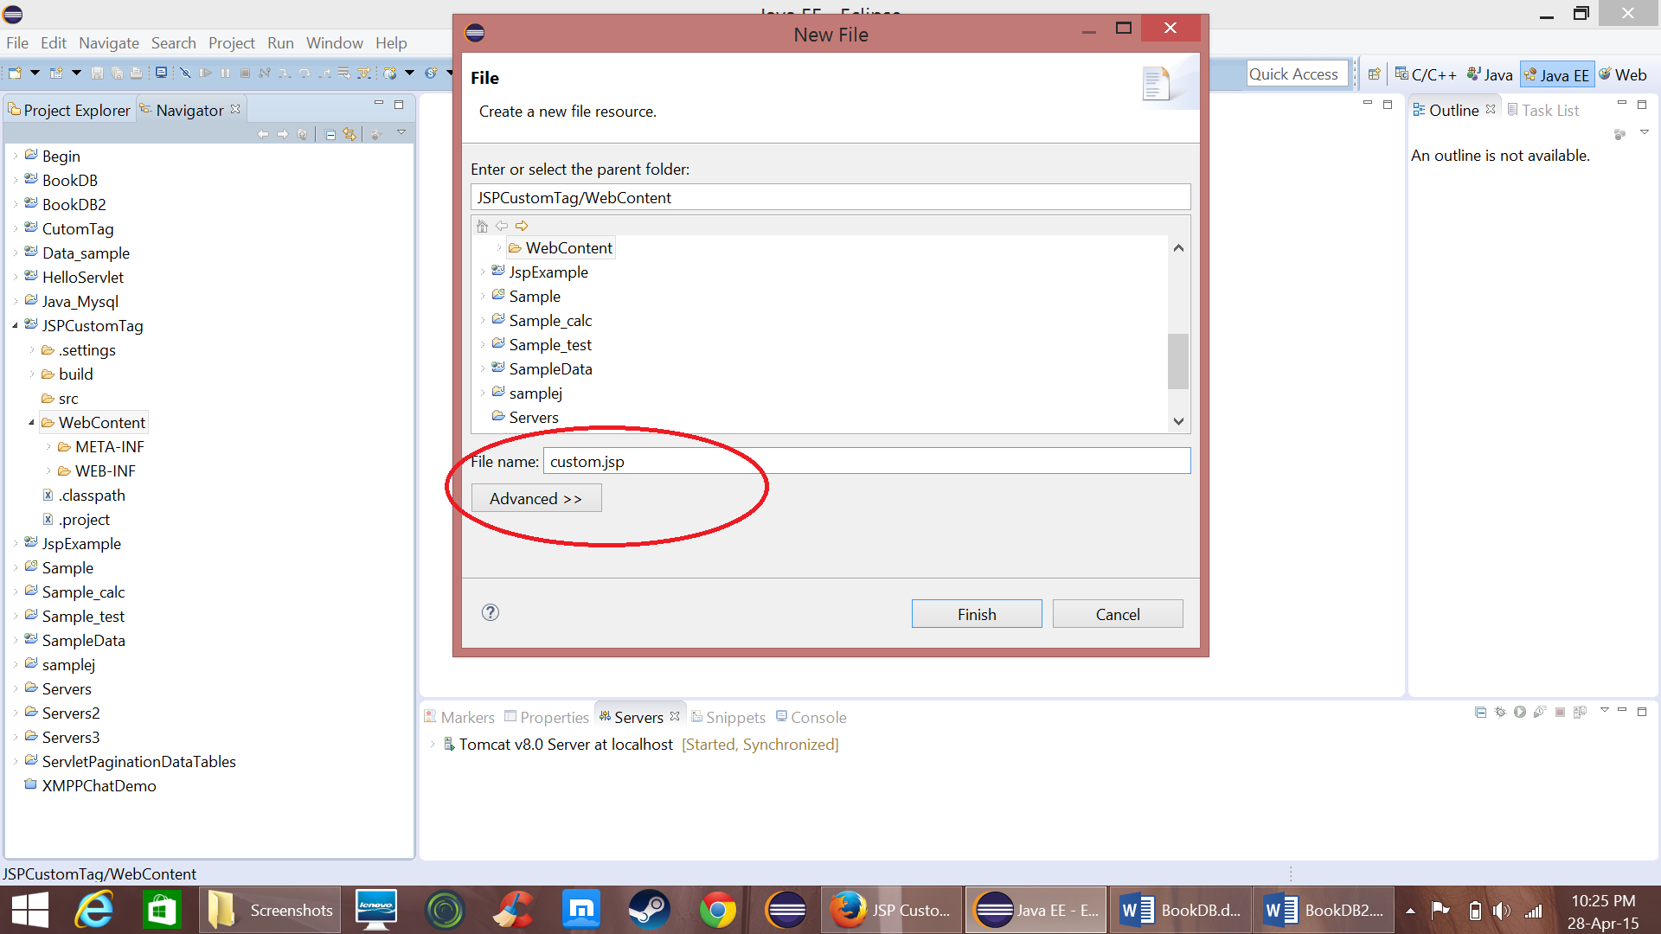Create a jsp file “custom.jsp”
* Now create a tld file to give the description about custom tag and a java file “Tag.java”

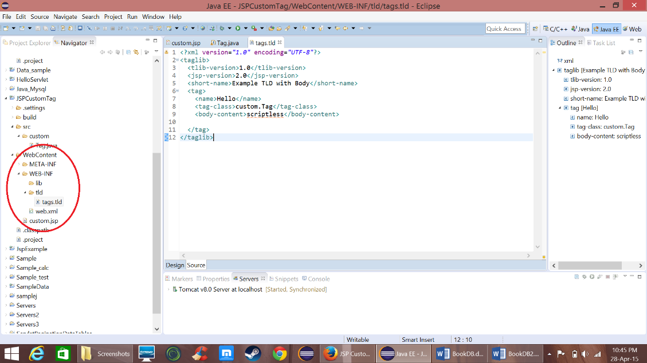

* 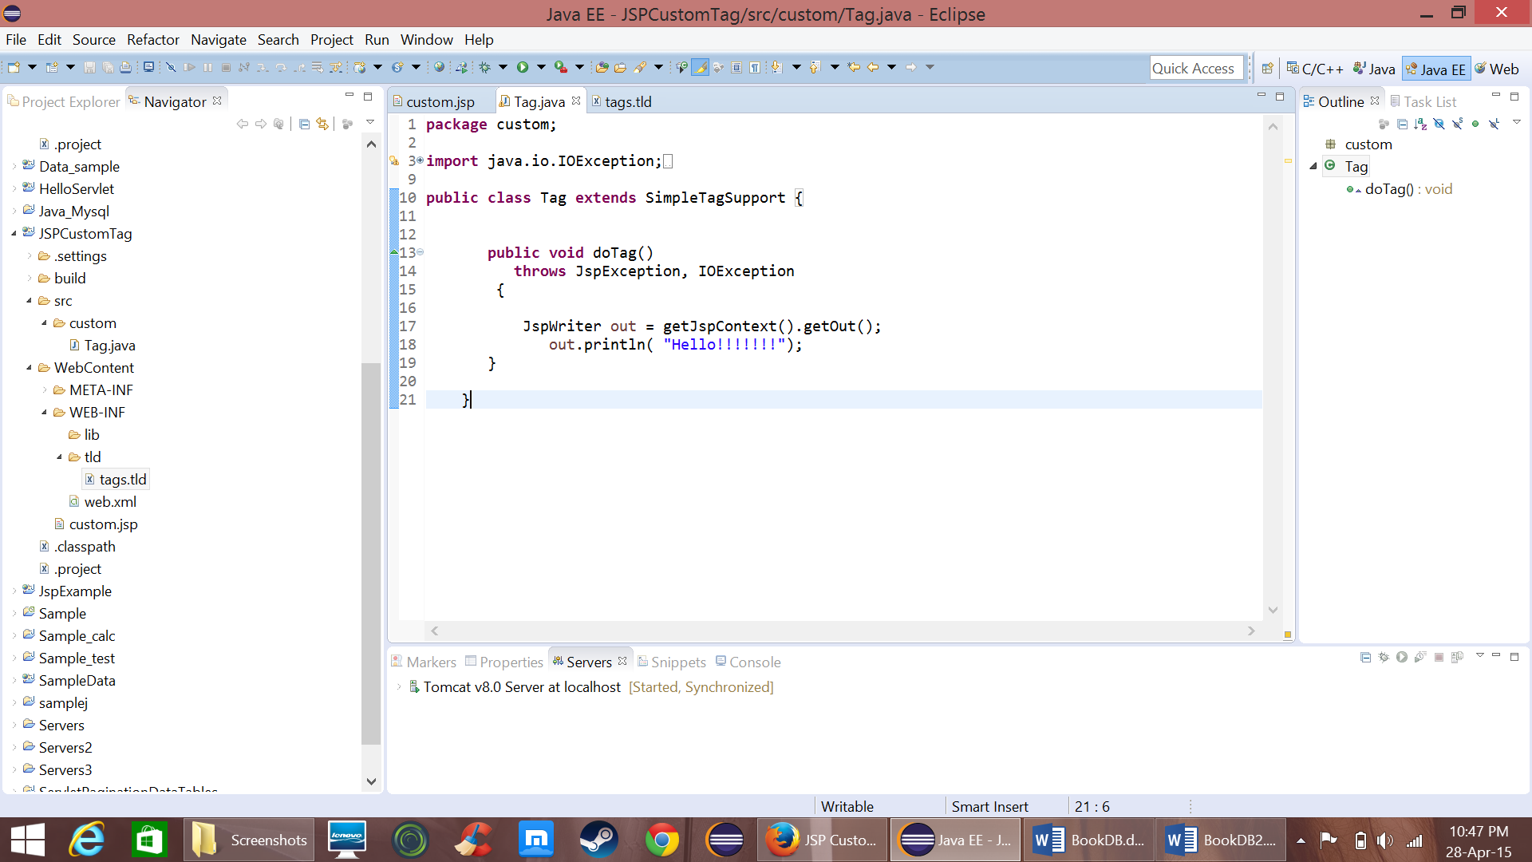Keep the following code in the java file

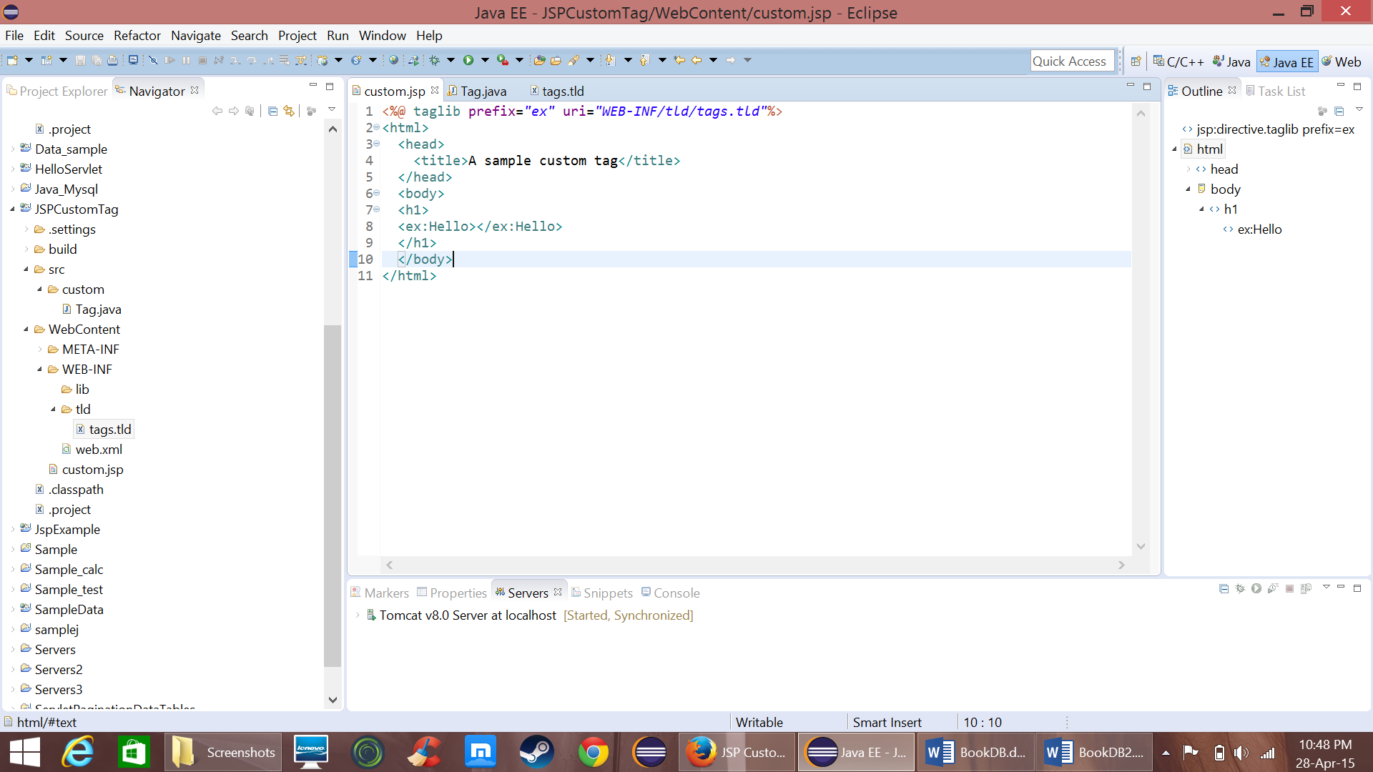Now write the following code in “custom.jsp”

* 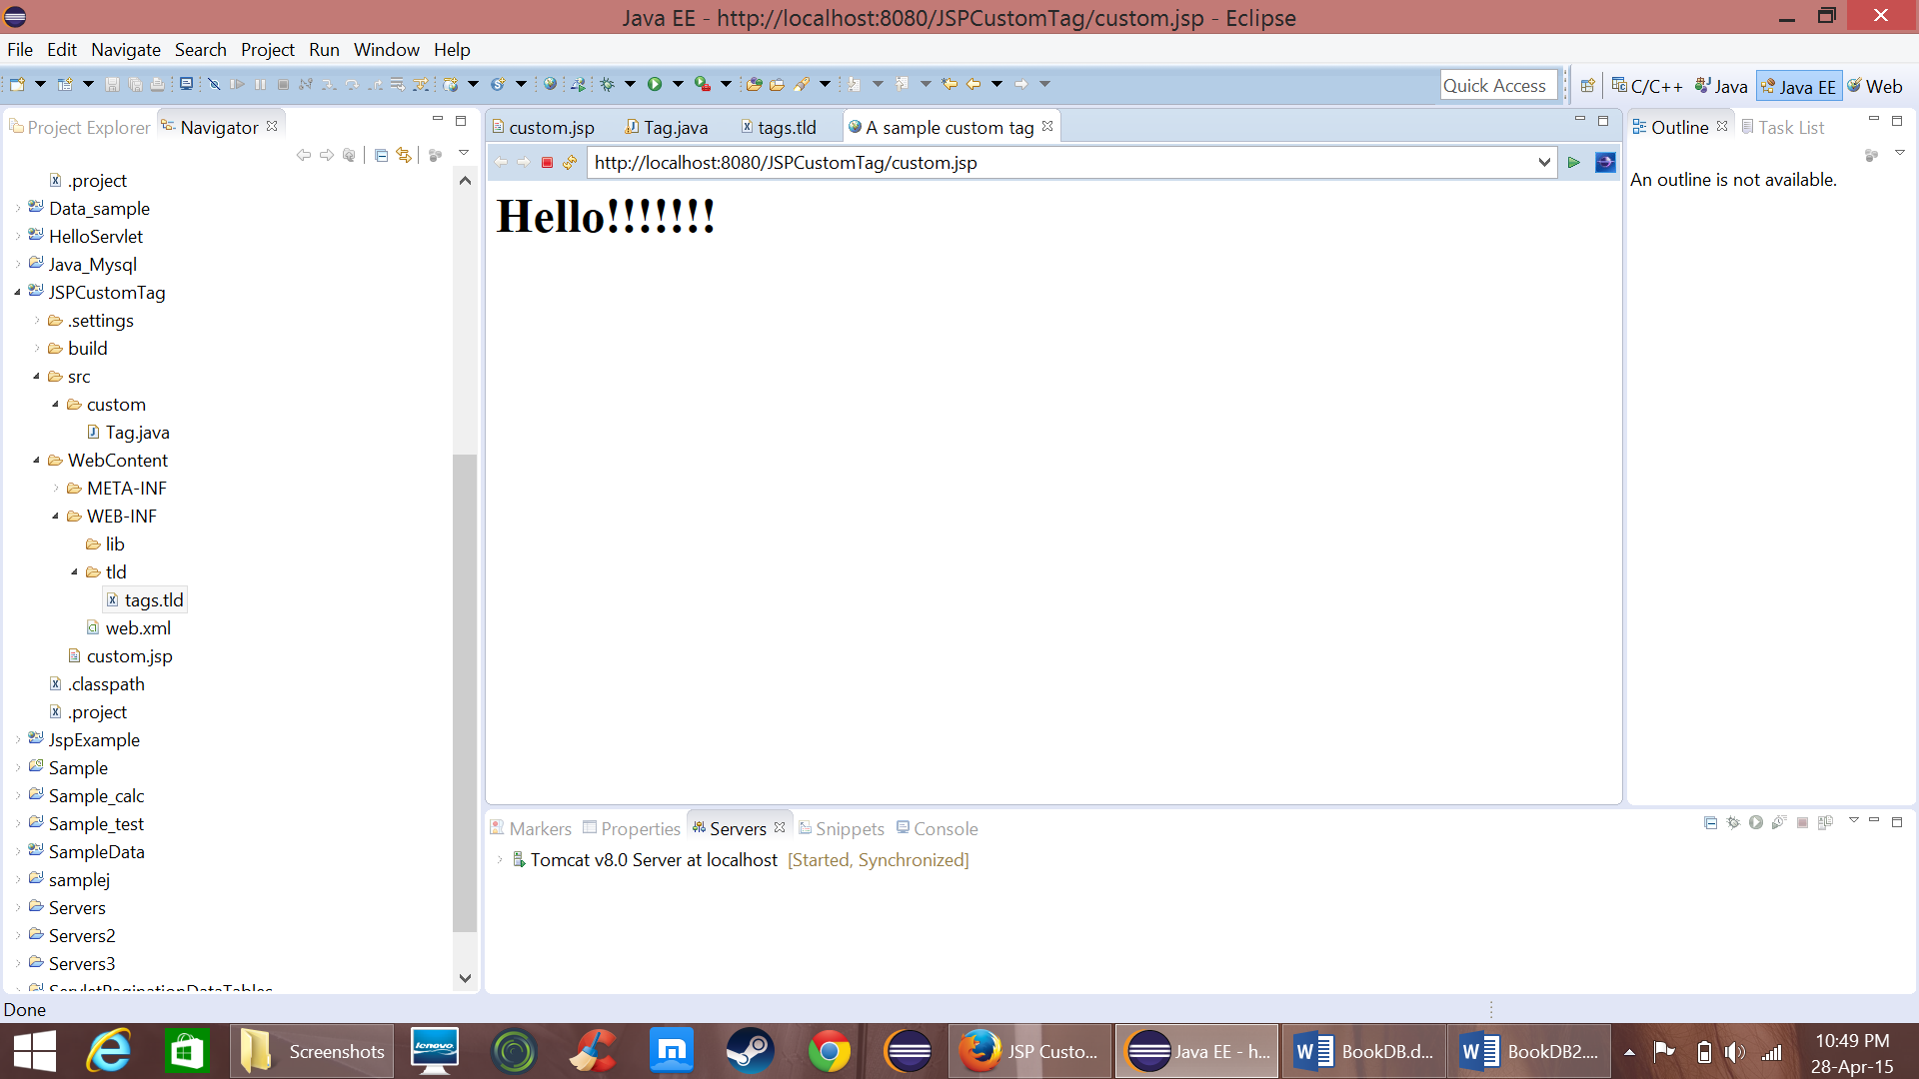Now run this on server

PART II

* Now similar to PART I create a dynamic project “BookDB2”
* Now import the java file that is used in assignment 1 “Dbconnect.java” and edit some of the methods by passing “connection” as a variable.
* 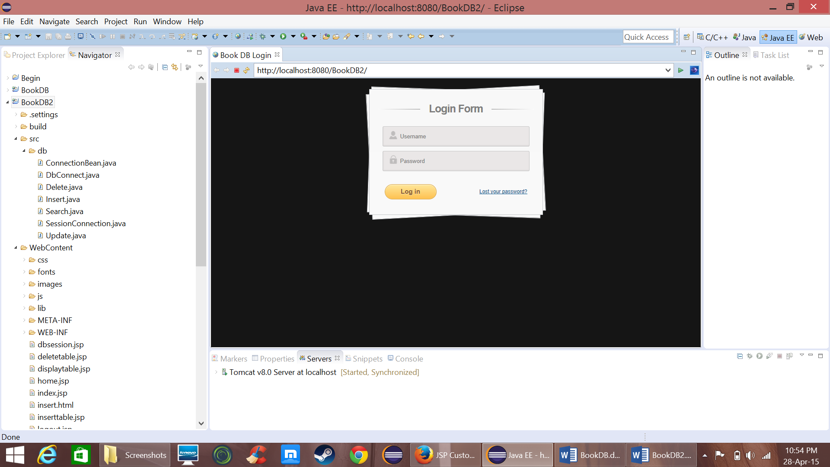Create a file “index.jsp” as a login page and redirect it to servlet “dbsession.jsp” when user clicks submit button.
* 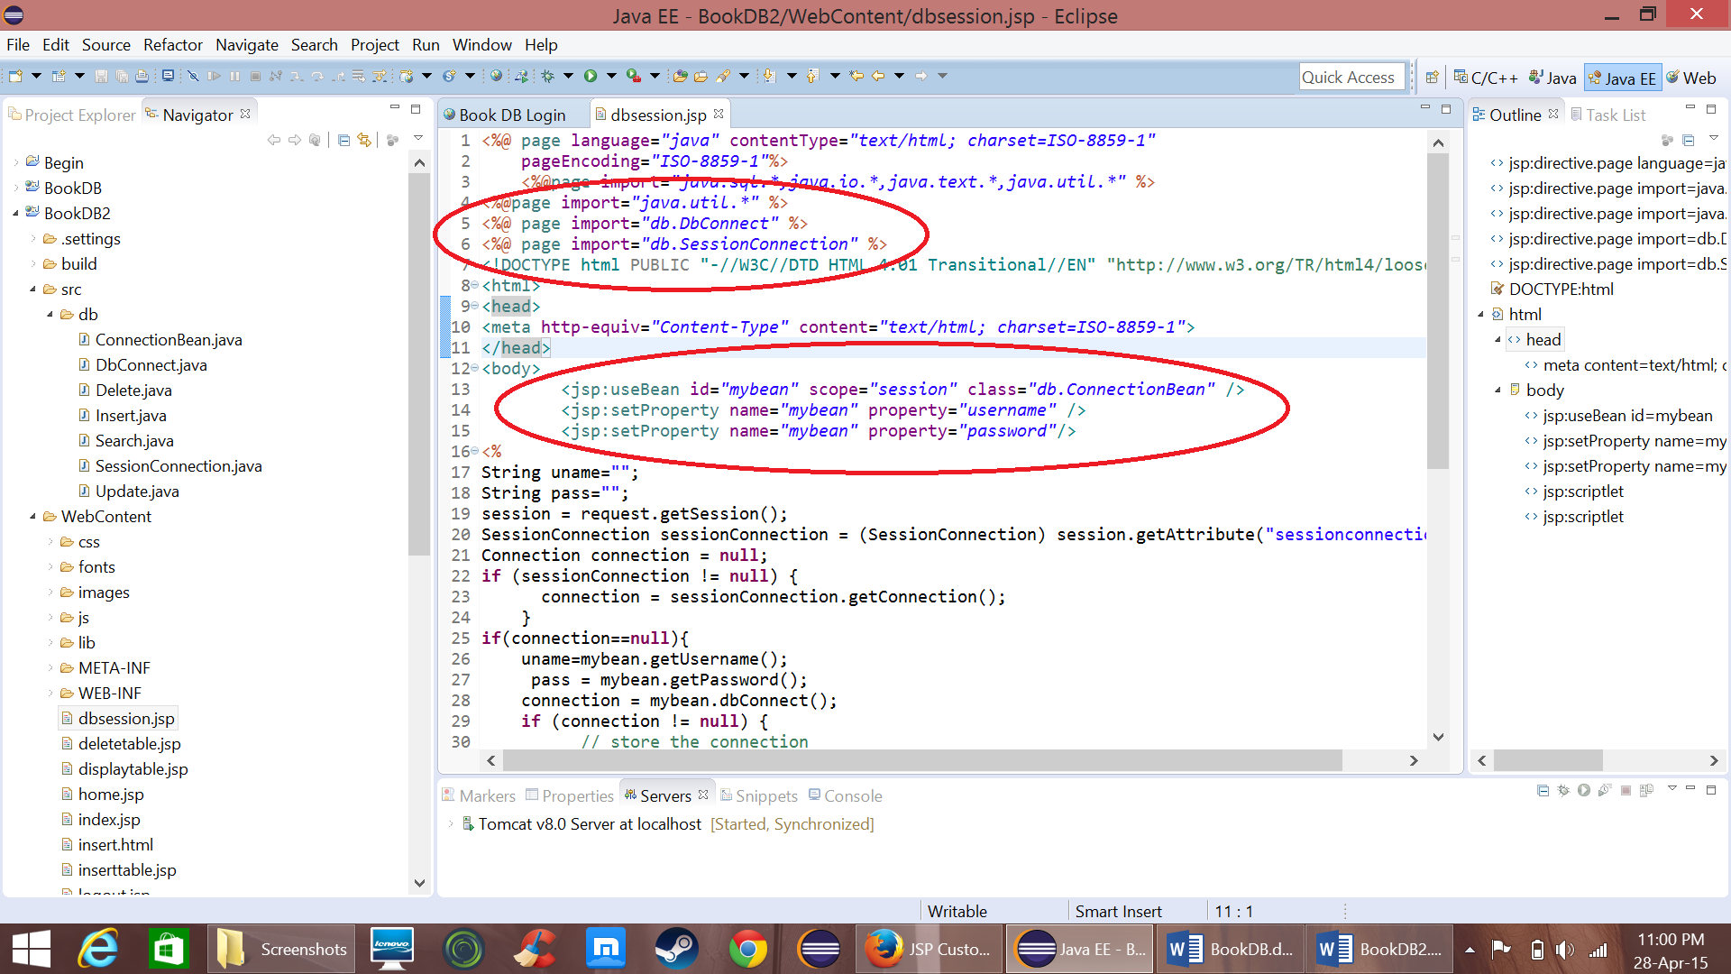Now in dbsession.jsp import “SessionConnection.java” (to store the values in session) “DbConnect.java” (methods for manipulating DB) and call the bean class “ConnectionBean.java” (to make a connection to DB)
* If the login credentials are correct it redirects to “main.html” otherwise “index.jsp”

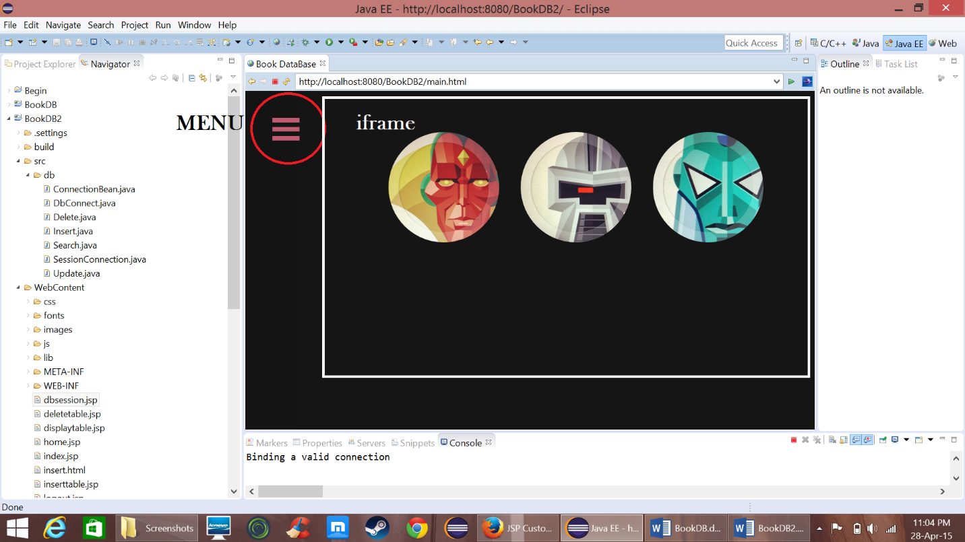

* The index page consists of a menu button and an iframe that displays respective page selected in menu
* 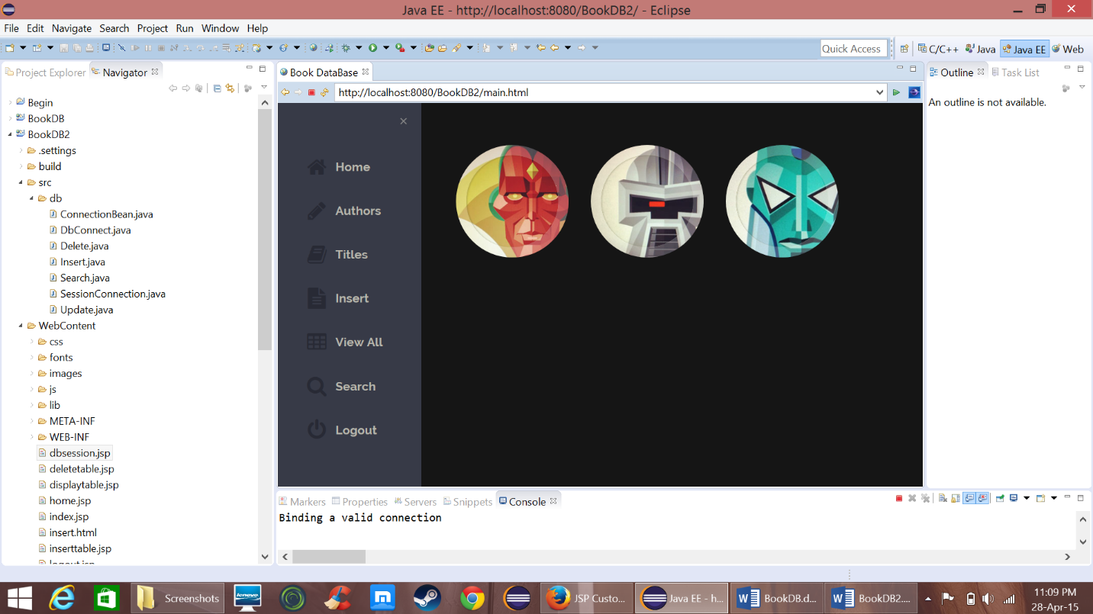On clicking menu button the menu will open
* On the home page you will the count of Authors, Titles and Total entries when the mouse is placed on the images in home page

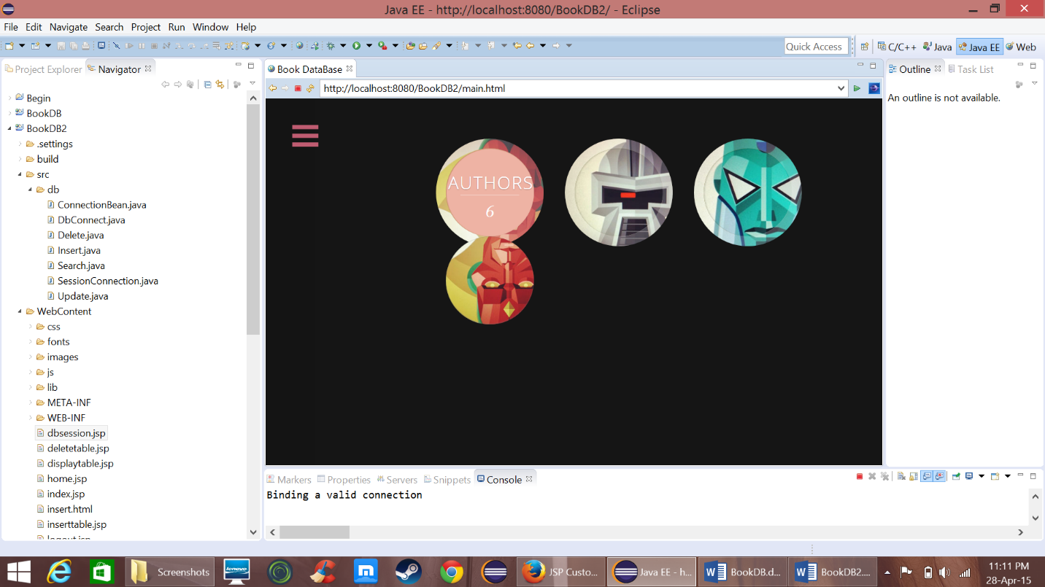

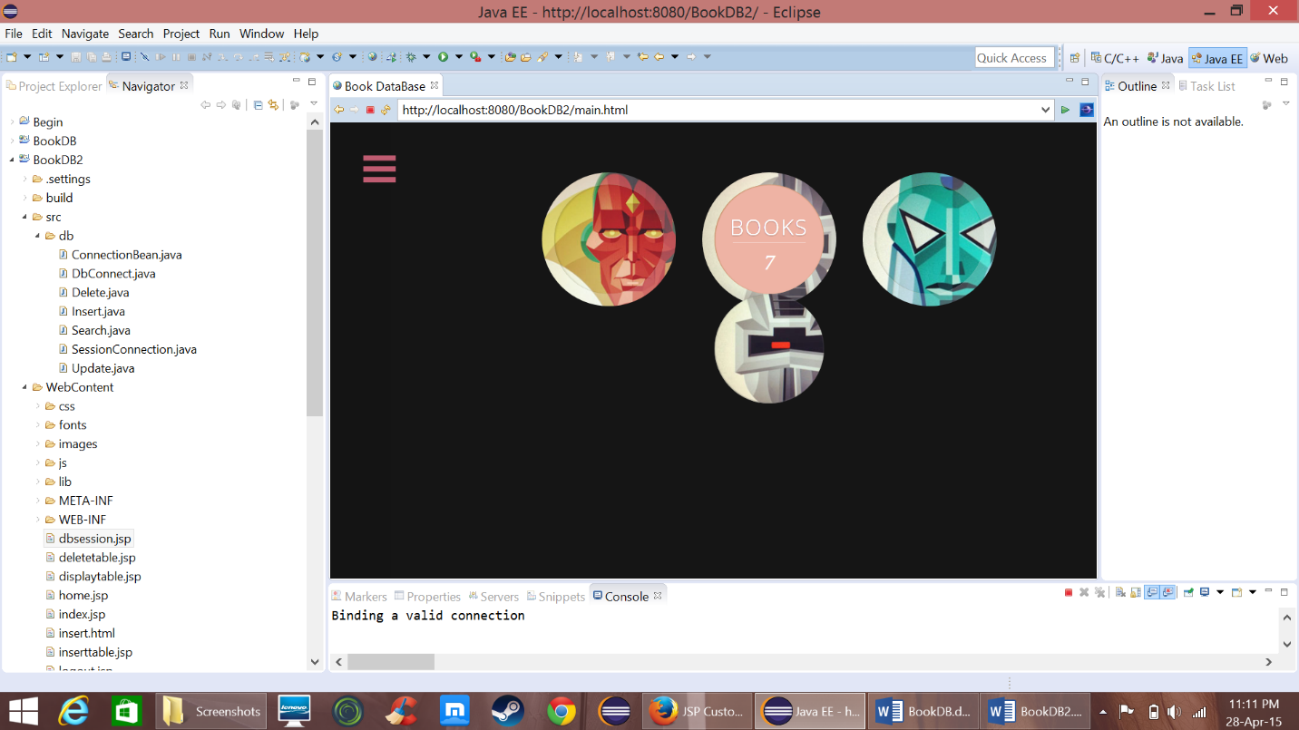

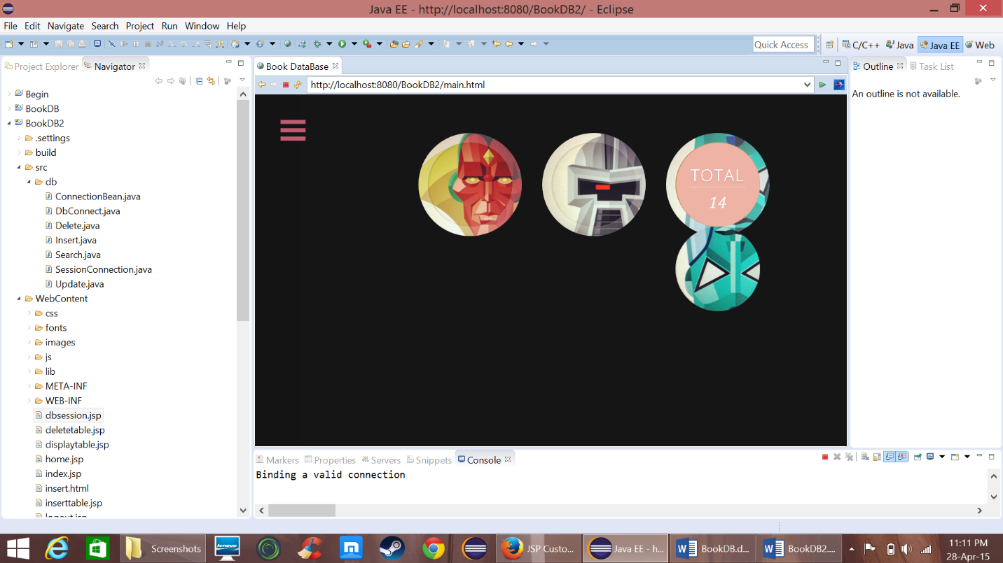

* Now click on Menu and click on “Authors” item to see the list of Authors.
* On clicking Authors the main.html page goes to “*displaytable.jsp?table=Authors”*

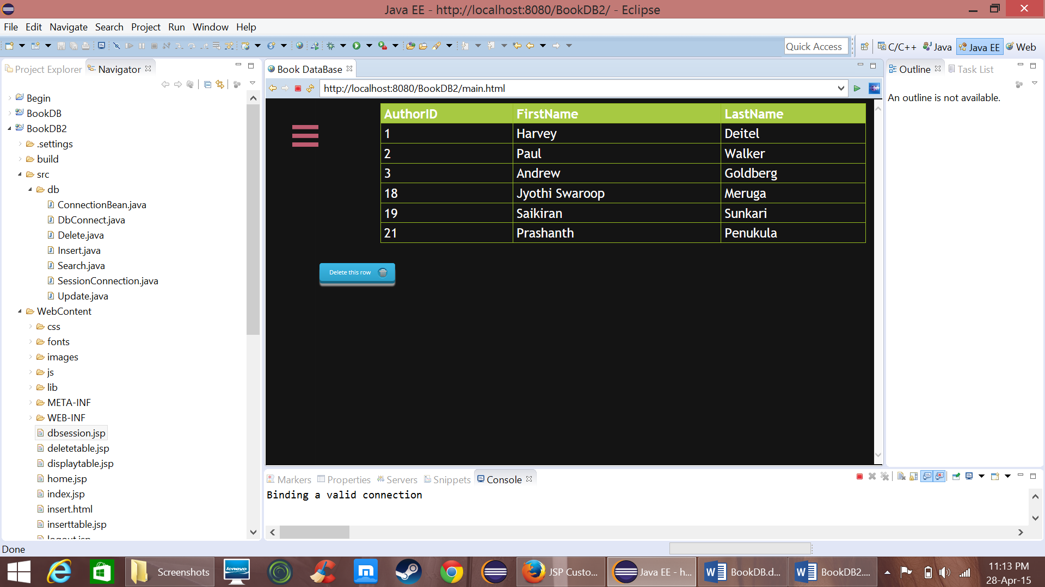

* The functionalities of this table is similar to that developed in servlets

**Update**

* To update a value just double-click on the value in the table and with the help of the javascript written it goes to update.jsp in which there is a custom that updates the values

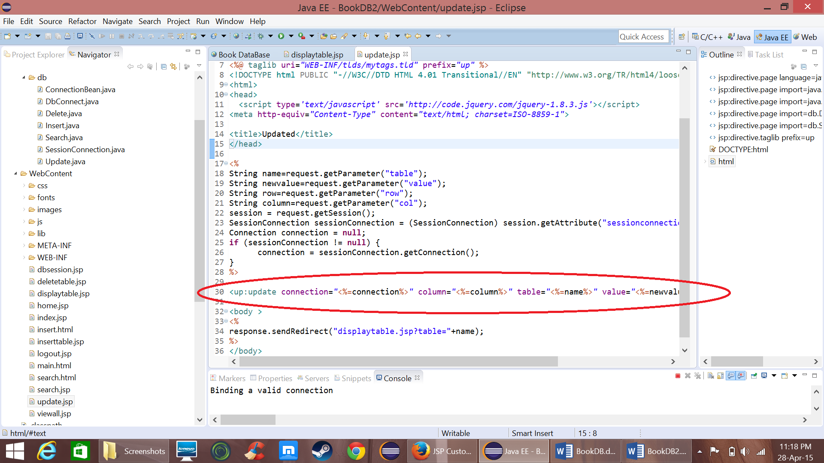

* The custom tag is defined in tld file “mytags.tld”

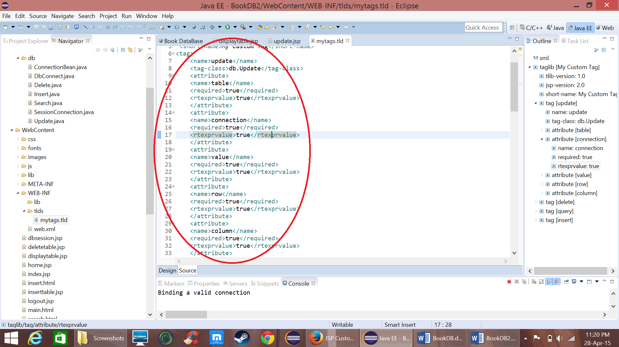

* The java file associated with update custom tag is below

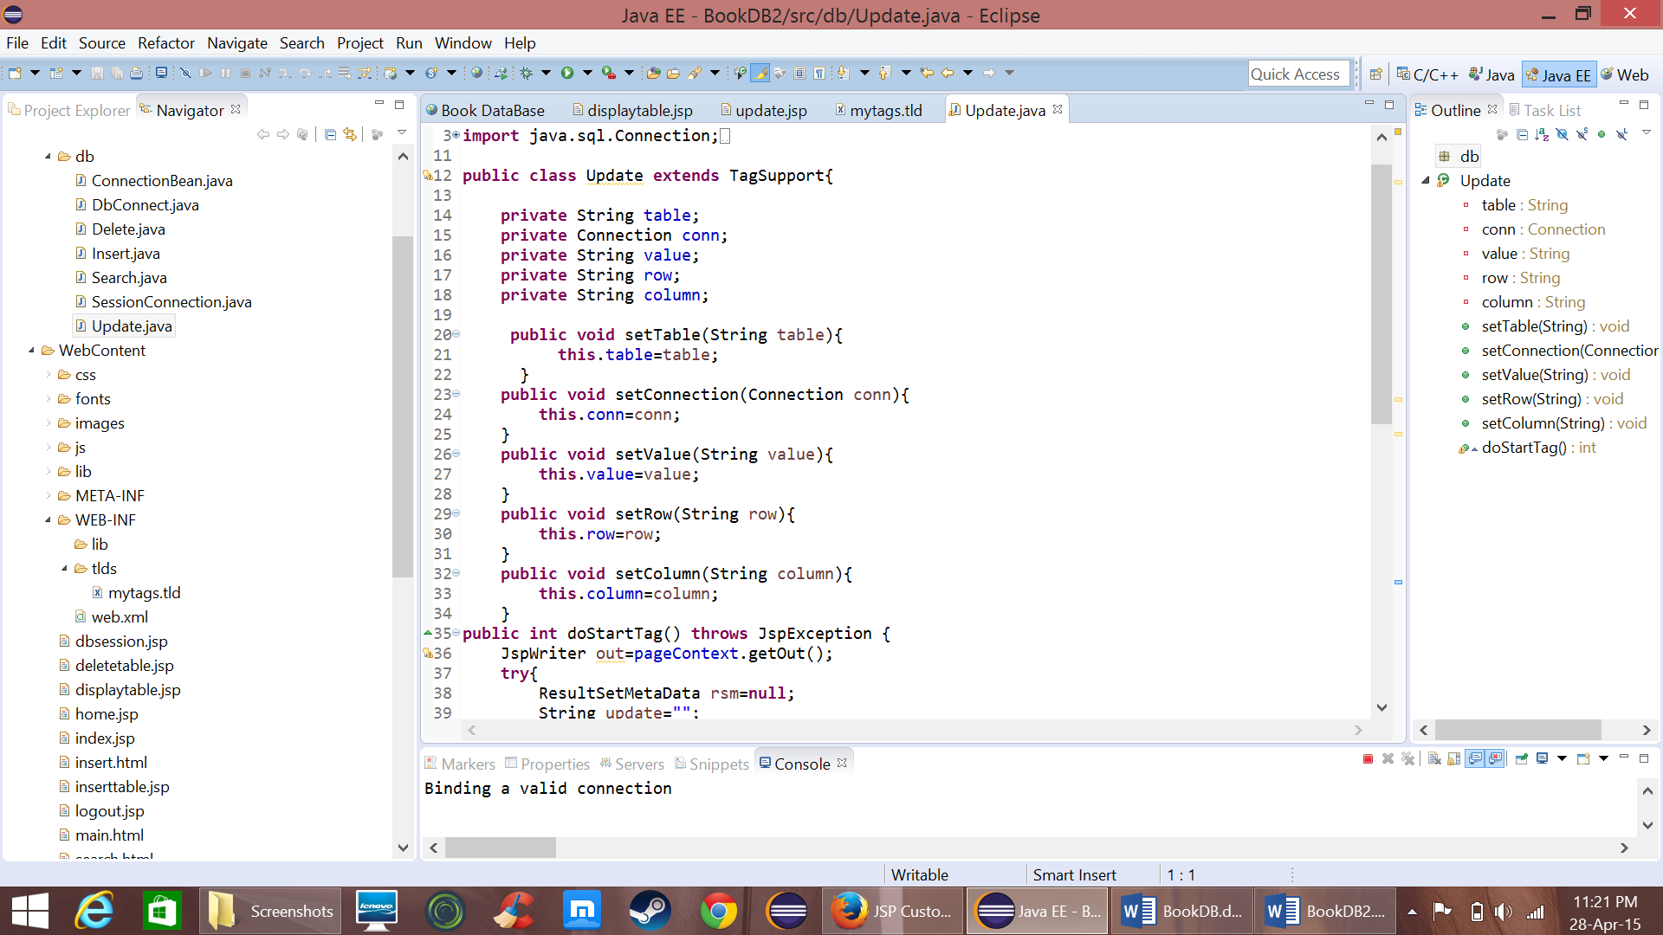

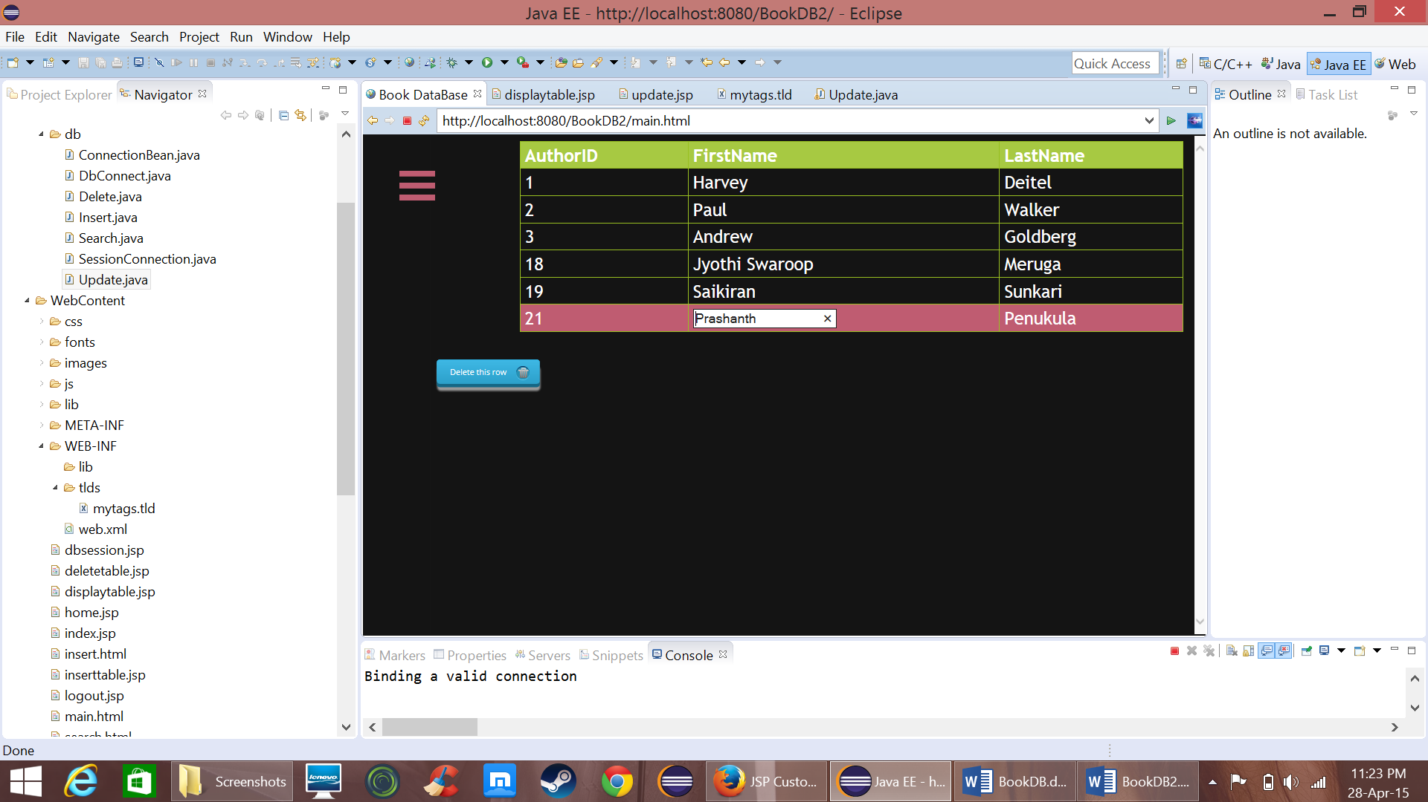

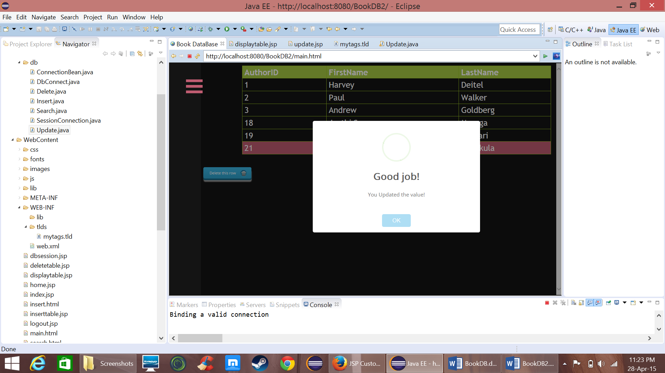

* Similarly for delete when user selects a row and press delete button the javascript redirects to “deletetable.jsp”

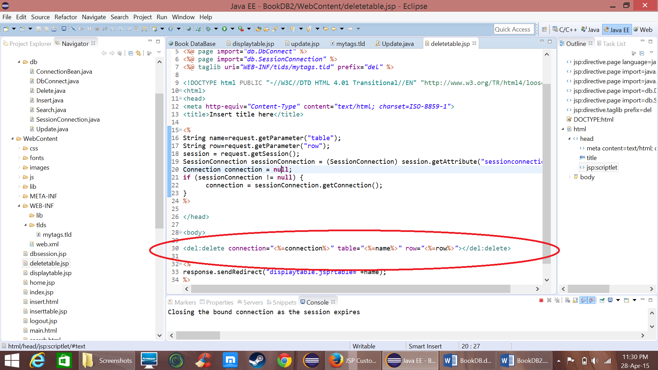

* In deletetable.jsp there is a custom tag that goes to Delete.java to delete from DB

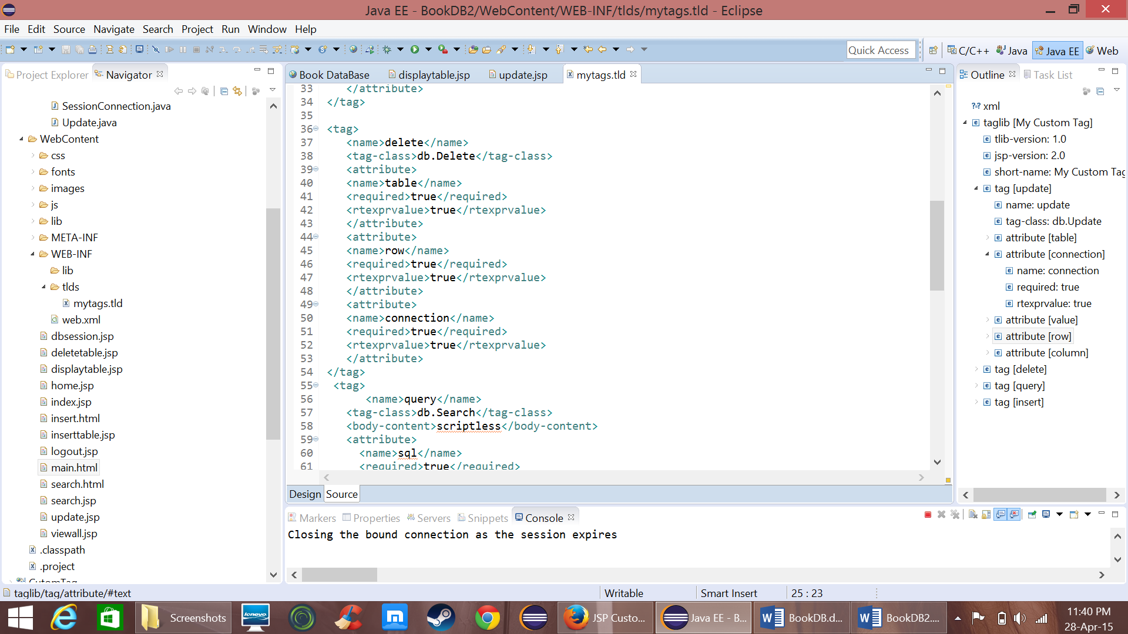

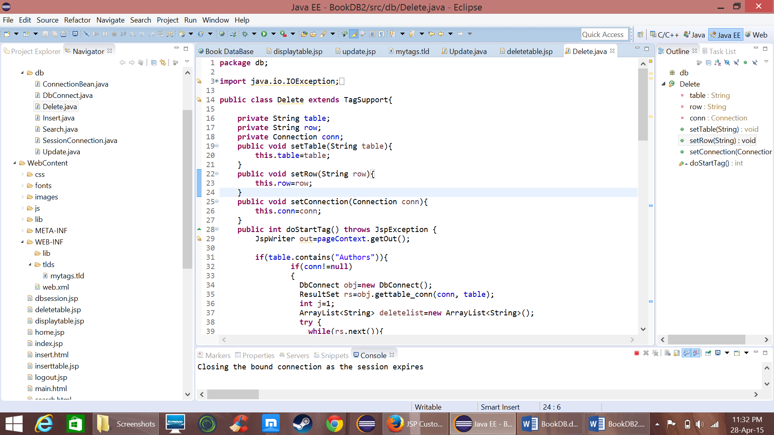

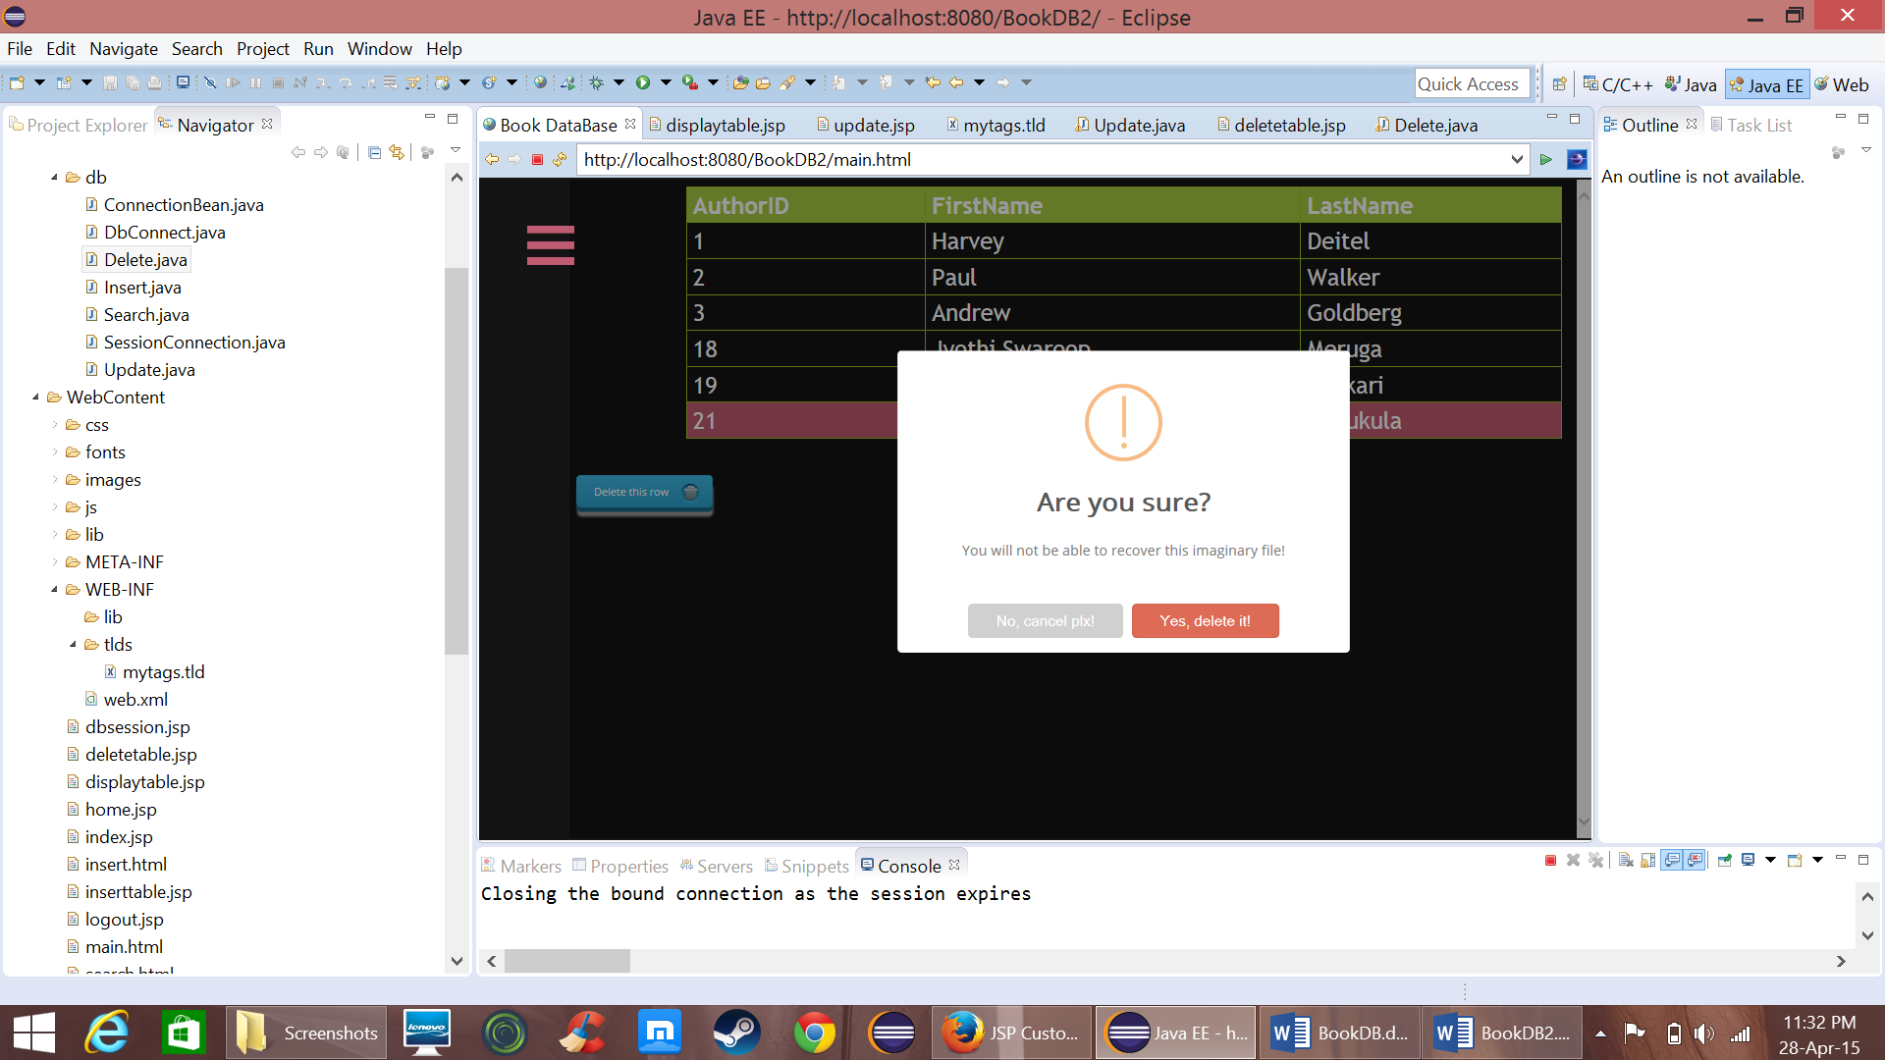

* Now for “titles” menu as when the user clicks it goes to “*displaytable.jsp?table=Titles”*

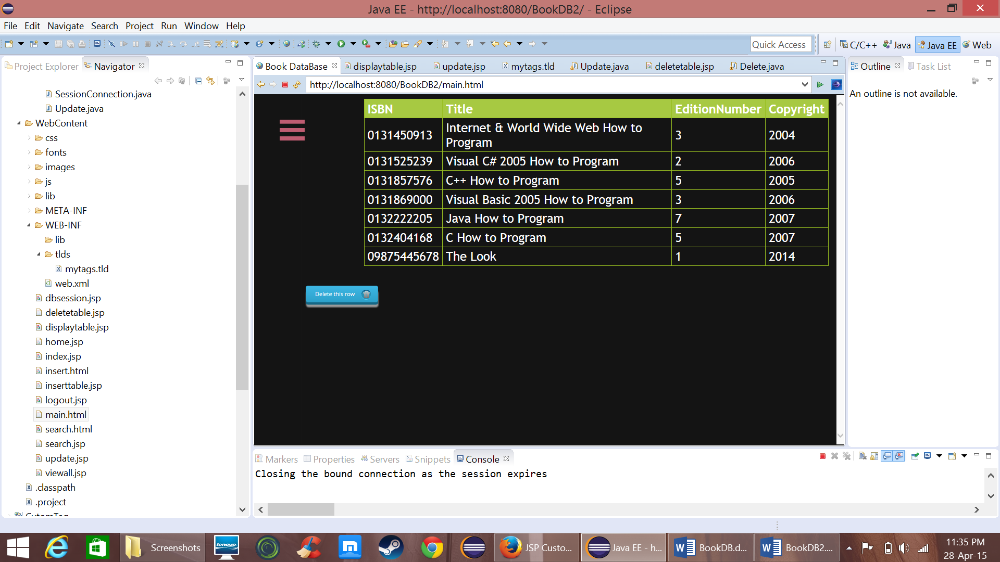

* Now click on Insert menu item and it goes to “insert.html” and when the user clicks the button it goes to inserttable.jsp and a custom tag in jsp file will update DB

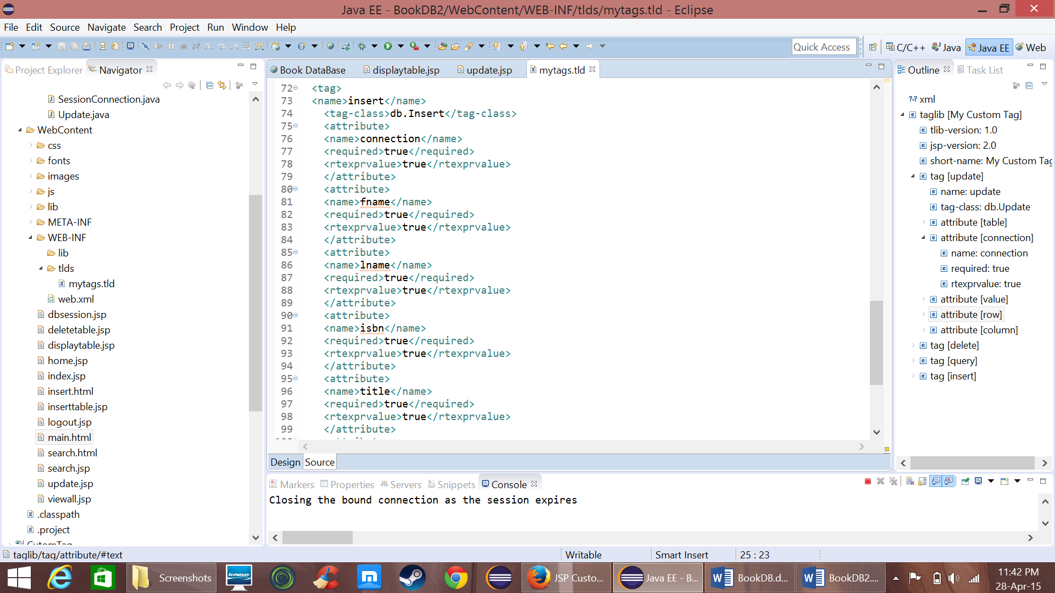

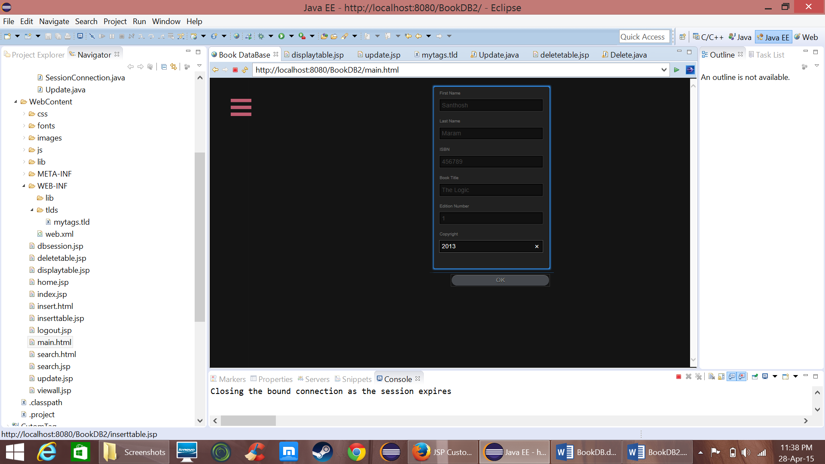

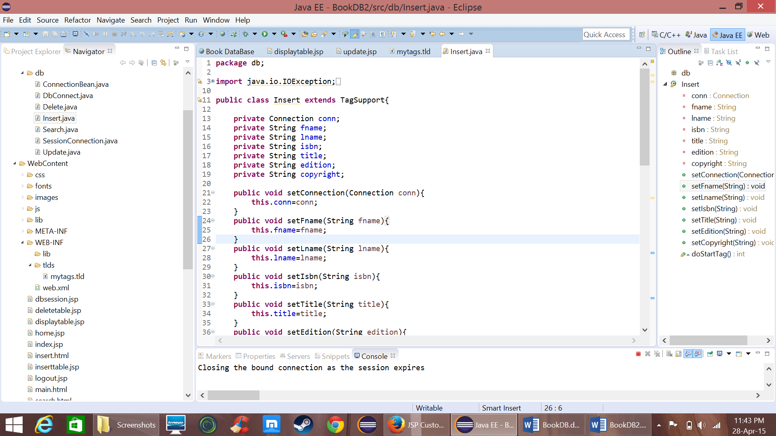

* Now for “View all” menu item when the user clicks it goes to viewall.jsp and displays all the data

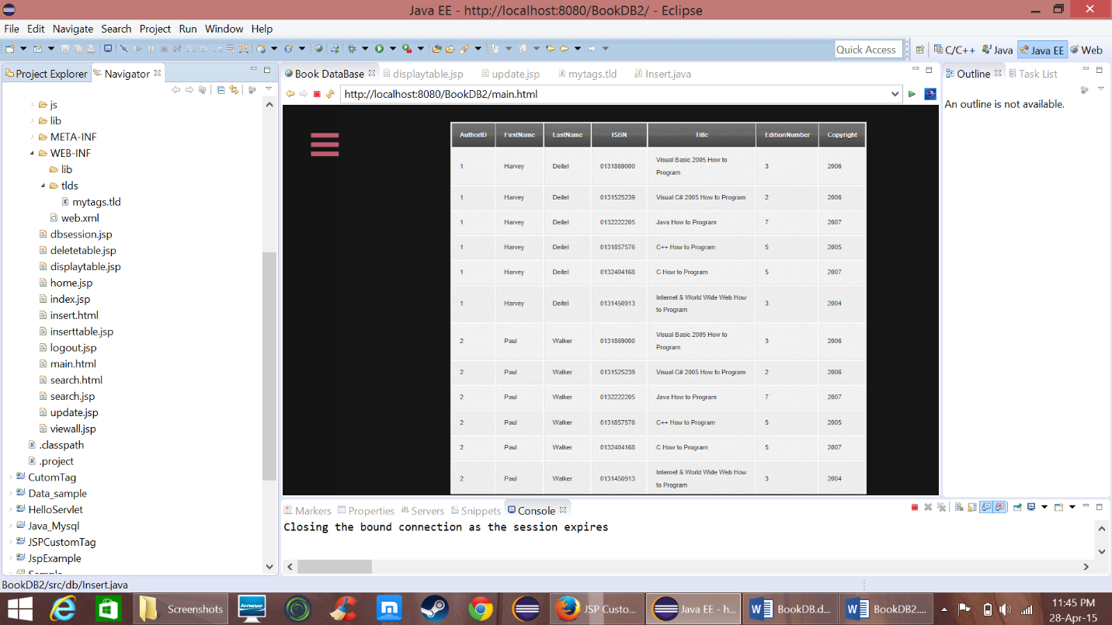

* Now for Search menu item it goes to search.html and when the user enter some text and clicks search button it goes to search.jsp in which a custom tag with query as attribute is used to display table

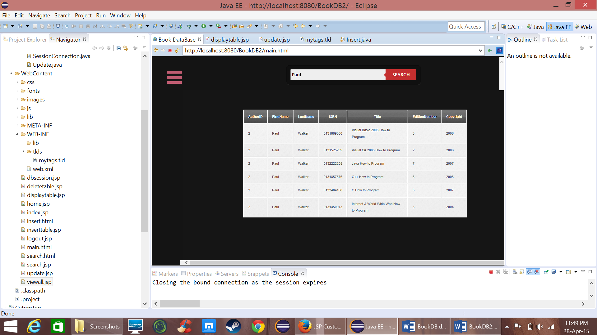

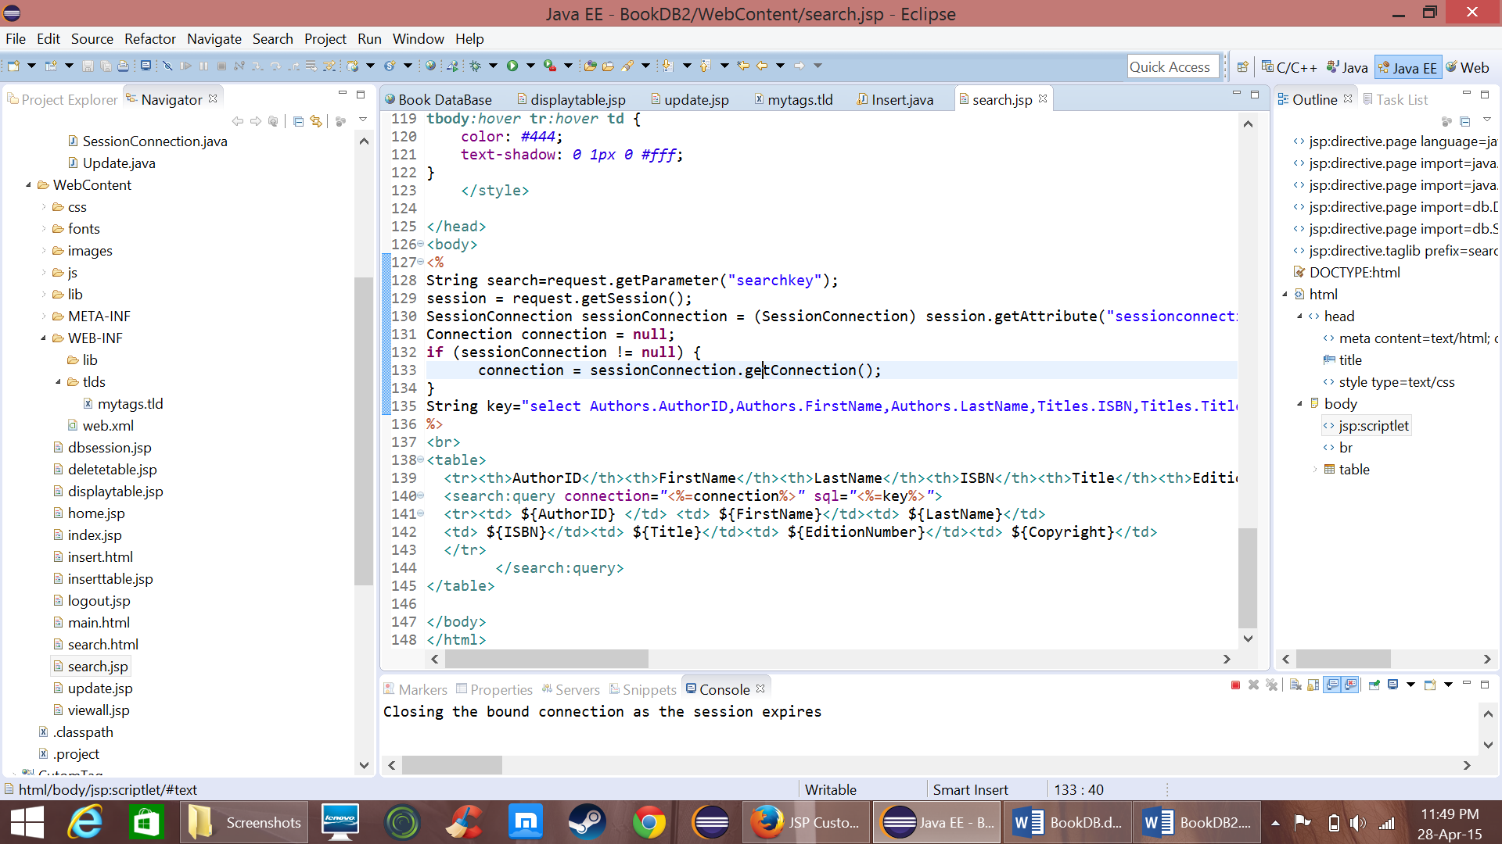

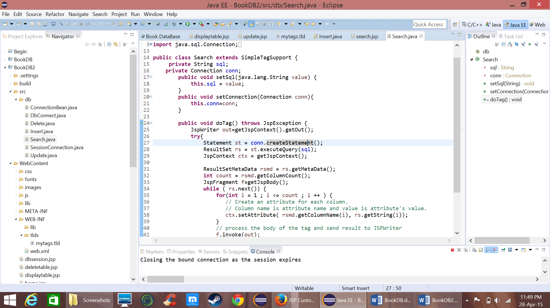

* Now when the user clicks Logout menu item it removes the connection attribute from the session and redirects to index.jsp

